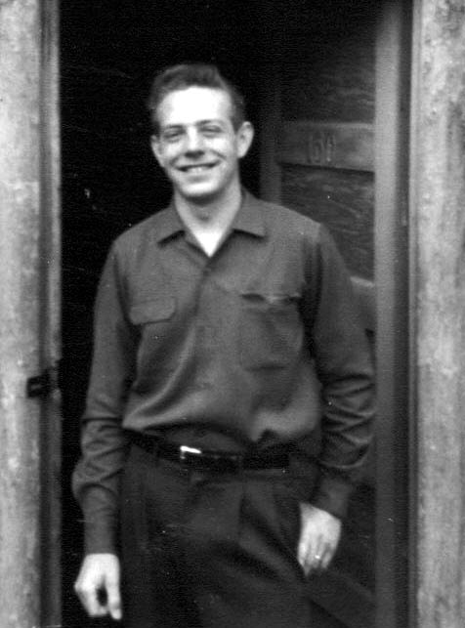**5 – KENNETH BROWNING – my boyfriend, my husband, my Eternal Companion**

Kenneth "Ken" Browning moved into our ward when I was a Sophomore in High School and he was a Senior. He moved down by Bonnie Draper and Connie Jones. He became friends with Hendrick Brandenburg, Buck Heines, & Butch Israelson. Hendrick became his best friend. Hendrick's family were from Holland but were strong members of the church. These friends of Ken's were dating girls who lived in Roy and went to Weber High, so Ken started dating girls from there also to double date with his friends.

I remember being impressed with Ken because he was so polite and friendly - good looking too. At MIA dances, he would ask lots of girls to dance, and would come to them and politely ask them to dance - not just come over and grab you by the hand and pull you onto the dance floor like the other boys did. When the dance was over, he would walk you back to your seat, or ask if he could have another dance. The other boys would just walk off and leave you standing in the middle of the floor after the dance was over. I noticed how he treated his mother so politely by opening the door for her and he opened the church door for any girl or woman. He was very polite and respectful. Someone has said that you can judge how a man will treat you by the way he treats his mother. Ken was very respectful and courteous to his mother, and they had a good relationship which made me feel good.

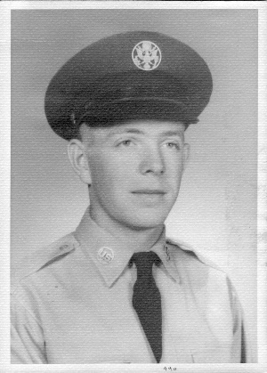 After Ken graduated from High School, he joined the Air force. However, he was sent to Texas for his basic training and he got a Heat Stroke while standing in formation on a hot summer day. When the Sergeant told them to fall out, he literally fell out. They took him to the hospital and packed him in ice. He ended up getting out of the military with a medical discharge. They told him they didn't want him there any longer to take a chance of having to pay his funeral bills. I guess Ken had had his first heat stroke when he was a boy in Idaho and had been fishing. This was his second and they said he was really lucky to have come out of it alive and then to not have brain damage was a miracle. They said if he had another one, it would take his life.

When he returned from the service, he wanted to get into college. He went to Idaho and lived with his Uncle Irven and Aunt Bernice, found a job at a gas station and tried to enroll in college, but the classes he needed were not offered until the next quarter. He worked and when the next quarter came, he still could not get into those classes, so he decided to come back home

I remember seeing Ken taking a lead part in our ward play soon after he got home. I remember thinking how handsome he was and how good he was in the play. In February of 1958, soon after the play, he called to ask me to go to the Stake Sweetheart Ball with him. We were to double date with his best friend, Hendrick. As it turned out Hendrick didn't go. I didn't find out, until after we were engaged, that he had asked several other girls to go and since it was a last-minute thing, they all had other plans. He was ready to quit trying when Hendrick asked him to call me - Hal's sister. He said he hadn't thought of me, didn't really even know me. I'm grateful to Hendrick for suggesting me. I had just broken up with Dallas again and Vern and Reny were in the service, so I was excited to go with Ken. I felt so comfortable around Ken. We could talk so easily with each other and found we had much in common. Ken was a great dancer and I was able to follow him easily, even though he put in different steps sometimes. We loved to dance together. I went off and on with Ken for two or three months. Then we started going steady. We went steady for about two weeks when I decided that Ken was getting serious. I had those plans of going to Heniger's Business College with Pat, after we graduated, and I wasn't ready to get serious. I told him we ought to date other people. But, even though I didn't wear Ken's ring, we were still together just about every night, as he came to my house every night. I guess he didn't want me to find anyone else as he had decided I was the one for him. He had told his mother, after our third date, that he was going to marry me. He told me later that when he came to pick me up for our first date, that he said to himself: “Wow! This girl is beautiful, how come I haven’t noticed her before?” He told me, after we were married, that he was sure the Lord put blinders on his eyes so that he couldn’t see me until after he was old enough to think of marriage. Ken was the assistant explorer leader in our ward so one weekend he went on a camping trip with them. I was still working at the Arctic Circle so one of the other girls who worked there wanted me to double date with her to the rodeo. She said the fellow I would be going with owned a new red Thunderbird. At that time that was about the best car you could own. It was a sports car. That excited me, so with my parent's permission, I went. I didn't like the guy I was with and the car didn't make up the difference. He asked me to go out with him the following night, but I turned him down. That was the only date I went on, other than Ken, from the time we started going steady.

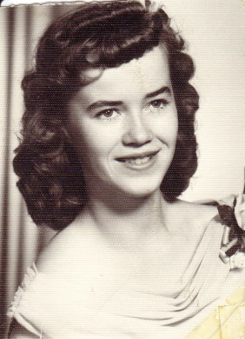 My brother, Hal, told me one day, "You'd better marry Ken. You won't find anyone who will treat you better. He won't step out on you and he has a testimony of the church so he will honor his priesthood and be the kind of husband and father you want." This was special coming from Hal who wasn't active in the church. I had a picture taken for Ken and made an 8x10. He loved it, but somehow, we lost the 8x10 and he was upset, but I still had small pictures, so this is the one.

After Ken & I started going together quite seriously, he would come pick me up when I got off work from the Arctic Circle. It was usually around 11:00 or 12:00 p.m. There was a slight disadvantage to this - guys from all over would come to the Arctic Circle and flirt with us. Lots of times they would ask us out or want to take us home. Of course, I couldn't because Ken was always waiting for me. But many times, it was an advantage because I wouldn't know the guys or wouldn't want to go with them and I could & would say "I'm sorry, but my boyfriend is waiting for me." After Ken and I were engaged, and I knew for sure that he was my "Mr. Right", then I didn't want to be with anyone else but him anyway.

In my Patriarchal Blessing, it told me that when I was ready to choose a mate that I should make it a matter of prayer and the Lord would help me find the right person. I began doing this after Ken and I had been going together for some time, and I soon had the answer - Ken was to be my Eternal Companion. I told him of this and began wearing his ring again.

Ken had always wanted to go on a mission. From the time he was a small boy, he said this was one of his greatest desires and goals. Several of the boys his age had been called in and interviewed to go on missions, but he hadn't.

We loved each other and wanted to begin making plans for marriage, but we both wanted Ken to fill a mission first. He went to the Bishop and told him that the two of us were in love; but that he wanted to go on a mission and that I had promised to wait for him. The Bishop told him that when two people find each other and are ready for marriage, that this is a mission too. When Ken told me about it, he felt bad and wondered why the Bishop didn't want him to go on a mission when he wanted to so bad. He has since felt bad many times, and felt cheated when other men talk about their missions and say how it's the best two years of their life. I have tried to tell Ken that I'm sure the main reason the Bishop didn't call him to go on a mission is because he was helping to support Roy on his mission. Roy had never wanted to go on a mission and during his teen age years, he was very wild and gave his folks cause for concern. He dropped out of school and ended up joining the military. While there he became converted to the gospel. He was always a member, but like my brother Hal, had never gained a testimony of it. While Roy was in the service, he did a lot of good and helped convert himself and some of his buddies. When he came home, he went to the Bishop and told him he wanted to go on a mission. Ken's mother was working at the school lunch program and said she couldn't pay it all so my wonderful Ken said he would pay half. He was working at California Packing Plant. So..... I'm sure that the Bishop could see that Ken was helping to send Roy on his mission and so there was no money for Ken to go. But we feel my Uncle Dale could have supported Ken as he has supported many missionaries over the years, or Ken's Uncle Irven & other relatives probably would have been glad to help, and the High Priest Quorum & Elder's Quorum could have helped. Oh well, that didn't happen. Ken supported Roy until we got married and then we continued to support him until he got home. We were blessed for it and glad we could do it. Not many girls do wait for their missionaries. They usually find another returned missionary who has returned earlier and marry them. So maybe, the Lord knew I might not wait and we were meant for each other. Whatever the reason, Ken has felt bad, but I told him that someday the two of us would go on a mission together. Well, I’ll insert here (04-21-06) that we did go on a mission together to the Philippine Islands from March 17, 2003 to February 17, 2005. When Ken was being set apart by our stake president, the blessing said that the Lord knew of the sacrifice he had made years earlier and that the He (the Lord) was pleased with him and that now it was his turn to go on a mission. Tears came to my eyes as I heard that blessing. I will tell more of our mission later on in this history.

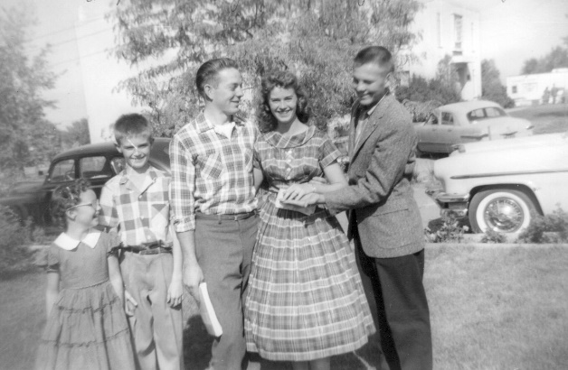**Ken gave me my engagement ring in October of 1958**. We had been to a Stake Harvest Ball. Afterwards we went to **Veldon Baird**'s home with him and his girl and several other couples. We ate, played games and watched the midnight "Chiller" show on T.V. We used to take turns at each other’s homes after dances. When Ken took me home, he parked and turned off the car. We began discussing the dance, party, etc. He took his ring off my finger, slipped the engagement ring on and asked me to marry him. I didn't take him seriously at first - until I noticed the ring on my finger and when I did I didn't answer him, I just squealed and hugged him. The next day was Sunday so the word soon got out. Monday morning when I got on the bus and my friends saw my ring, they screamed. Poor Joe, the bus driver, this always happened when someone got their engagement ring. I was the second my age to receive one. Margie got hers about a month before. Pat got married in November of our senior year - not in the temple as she wasn't a member at that time. I can't remember when she got her engagement ring, but she lived in Syracuse at that time - so didn't ride our bus.

My parents, brothers and sister were all excited and happy. Mom felt I was a little young as I was only 17, but we assured her that we would wait until I graduated before we got married and I would be 18. We did. We were engaged 8 months.

I don’t remember having a birthday party growing up. I’m sure it was because my birthday was just 3 days after Christmas and everyone was partied out and had no money to buy more presents. Mom would always bake me a birthday cake and we would have ice cream and she & dad would give me a couple of presents, but I always wished my birthday was in the months of May, June, July, August or September. Now that I am married, it doesn’t matter. Ken gave me a couple of surprise birthday parties. The first was when we were engaged. He had talked to Mom about having it at our home and he talked with all my friends about coming over after Sacrament Meeting at night. Ken’s brother, Bob, was home on leave from the military and he was a baker, so Ken asked him to make me a birthday cake. I was really surprised and happy about the party and we had a fun time, mainly visiting and eating cake and ice cream. When I cut into the cake, I was surprised because the color was “royal blue”. Bob had wanted it to be white and to make it even whiter, he would just put a drop of blue coloring into the cake batter. This time he slipped, and a lot came out. It wasn’t white, but a beautiful blue. I loved it, I thought that was great! He had decorated it so beautifully too.

**A funny thing happened about another engagement ring.** It was a fake ring that Hal had bought. He told me to put it on and show dad. I did, and to my surprise, Dad was really excited. I had been going with Bob Mansfield (Reny) and broke up with him and was just starting to go out with Ken. Dad thought that Ken had given me the ring and although I was very young, he was relieved that I wasn't going to marry Reny. He knew that Ken was such a good guy - so he was excited. I was really surprised because I had expected him to be upset. Then I told him it was a fake ring that Hal had and we all laughed.

**Spiritual Experience:** Like I said, Ken and I were engaged for 8 months. That is too long when you are in love. When we would come home from a date, we would sit in the car and neck for a while and that’s not healthy. We didn’t end up making love, thank goodness, but there was one time that was too close. Sometimes, instead of sitting in the car, especially during the winter when it was cold, we would go inside as Mom, Dad and the children were already in bed and asleep. We were quiet, and I would sit on his lap as he sat in the comfortable sofa chair. One time we told each other that after we were married, we would sit all night that way in a comfortable chair in our home – but we didn’t. Anyway, this night we had been to a formal dance. I had on a beautiful formal and as we stood together and kissed in my parent’s living room, Ken started to unzip my formal. Just at that time, we saw Mom walk out from her bedroom; come up the hall and into the bathroom. I knew it was Mom because she had on her nightgown and her hair was wrapped up with toilet paper and clips to keep it nice (as she had her hair done each week) and then a light cap over it. We froze, and Ken quickly zipped my dress back up. We waited and waited, but Mom never came back out. Finally, I went to the bathroom and looked inside, and no one was there. I then knew it was **my guardian angel** who we had seen. Ken and I then both knelt down by the couch and thanked Heavenly Father for sending my guardian angel to stop us. I doubt if we would have gone all the way as we were not alone in that house, but we might have petted. We have thought about that at different times and know we were blessed because we were praying night and morning and we would pray for strength to do what was right and safety as we dated, and we were trying to keep the commandments of God.

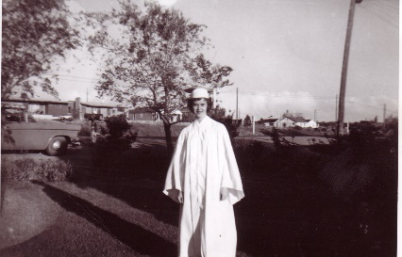

I graduated from High School the end of May 1959. We had a “Senior Sluff”, where all the seniors got to have the day off from school and do what they would like. Me and many of my friends went to Pine View Dam and had a fun time, swimming, sun bathing, eating our lunch, visiting and having fun. Prior to my graduation, Ken took pictures of me (I’m sure Mom did also). It was exciting to finally be graduating and then soon after getting married and starting a new life with my sweetheart, Ken Browning